Chapter 6 summary

Atmospheric moisture

The water cycle refers to circulation of water in the earth system, particularly the evaporation (evapotranspiration) of water into the atmosphere and condensation of water as precipitation. Remarkable properties of water include its specific heat or heat capacity, which we have noted extensively.

The shape of the water molecule (like Mickey Mouse’s ears) produces an attraction between the positive and negative sides of neighboring water molecules, causing surface tension. We may think of surface tension in considering how a water droplet will form in the atmosphere from dispersed water vapor. (Surface tension also allows a spider to “walk on water”)

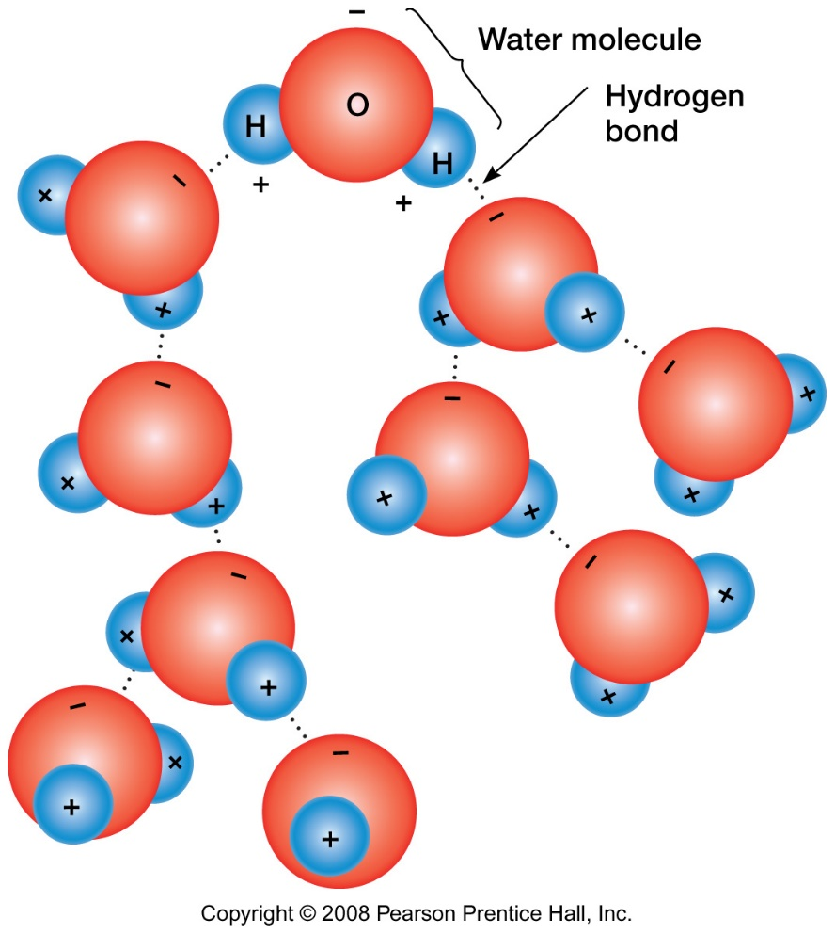

Most materials are denser as solids than liquids, however, water is not. Ice floats rather than freezing from the bottom up in water bodies.

Water also moves upward, against the force of gravity, with capillary action.

Water is often called a “universal solvent” because many substances dissolve in water.

***Phase changes*** of water between vapor (gas), liquid, and solid (ice) are very important in understanding how water enters and leaves the atmosphere.

***Latent heat*** is stored heat (energy) and refers to a quantity of heat, based on the type of material, amount of material and temperature of the material storing the energy.

***Sensible heat*** is sensed or “felt” heat, measured by temperature, e.g., we sense warm or cold relative to the temperature of our bodies and skin.

***Specific heat*** is the heat capacity or heat storage capability of a substance, which is the energy required to raise its temperature or the energy released in lowering its temperature.

Water has a specific heat of 1, meaning it takes 1 calorie to raise 1 gram of water 1 degree C. Most substances have a much lower specific heat than water and will be measure as a decimal of 1.

As ***ice melts***, sensible heat is converted to latent heat. As ***water evaporates***, sensible heat is converted to latent heat. For example, on a hot summer day, wearing a wet cotton shirt will cool your body while water evaporates from the shirt, drawing heat away from your skin. As ***water condenses***, latent heat is converted to sensible heat. When water is condensing in the atmosphere, the air around it heats up.

***Water vapor in the atmosphere: Humidity***

Evaporation occurs more readily from warmer water than cooler water. Warmer air will hole more water vapor for its volume than cooler air. Water vapor in the air exerts a physical pressure, known as vapor pressure and the maximum vapor pressure at any given temperature is the saturation vapor pressure.

***Measures of humidity:*** humidity is the amount of water vapor in the air.

***Absolute humidity*** is the mass of water vapor in a volume of air (e.g., grams of water per cubic meter of air)

***Specific humidity*** is the mass of water vapor in a mass of air (e.g., grams of water vapor in a kilogram of air). The maximum specific humidity is based on temperature, shown by the red line in the figure (below).

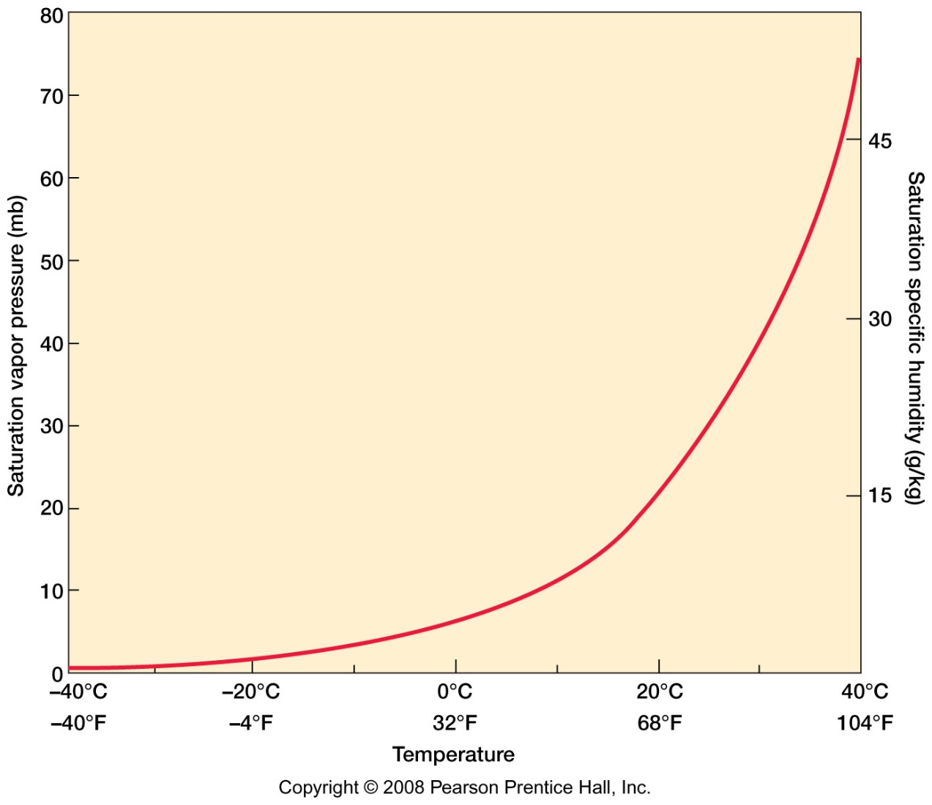

***Vapor pressure*** is measured in bars or millibars (mb). The water vapor capacity is the maximum amount of water vapor the air can hold at a given temperature.

***Relative humidity*** is the way we typically describe humidity (e.g., in the weather report). Relative humidity is the water vapor in the air relative to the capacity of the air at a given temperature, expressed as a percentage. For example, 50% humidity is half of capacity and 100% humidity describes saturated air.

Our lab focuses on the relative humidity of a mass of air as it ascends over a mountain range and descends on the other side (as below).

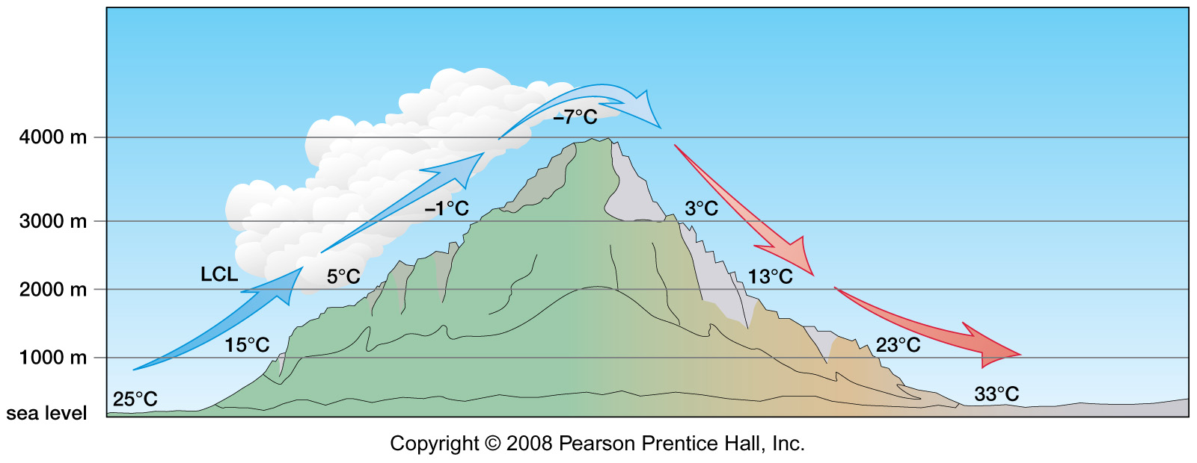

The lifting condensation level (LCL above) is the altitude at which the air is saturated, condensation begins, and clouds form.

Condensation is a collecting, gathering, or coalescing of water into droplets. Raindrops will be held together with surface tension on their edges (rather like a water balloon) and merge into larger drops.

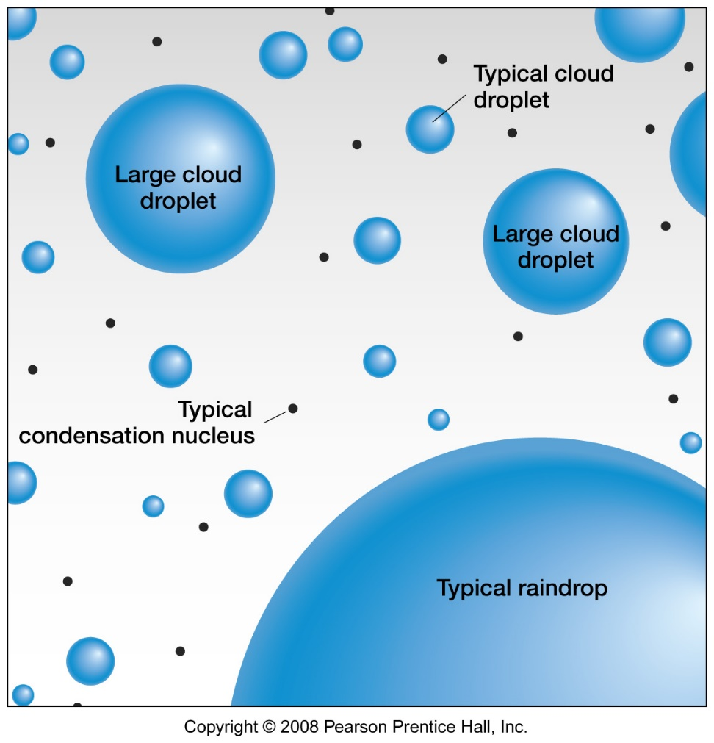

***Adiabatic processes*** refer to changes in air temperature as it moves up and cools because of a density decrease or moves down and warms because of a density increase.

The average rate of adiabatic cooling in undersaturated air is the ***dry adiabatic rate (DAR)*** or dry adiabatic lapse rate (DALR). Air decreases in temperature at an average rate of 10 degrees C per 1000 meters or 5.5 degrees F per 1000 feet as it rises. The average rate of adiabatic cooling in saturated air is the ***saturated adiabatic rate (SAR)*** or saturated adiabatic lapse rate (SALR). Air decreases in temperature at an average rate of 6 degrees C per 1000 meters or 3.3 degrees F per 1000 feet as it rises.

***Clouds*** are a visible expression of condensation in the atmosphere and are a source of precipitation.

Cirriform clouds are thin and wispy clouds, composed of ice crystals (shown below).

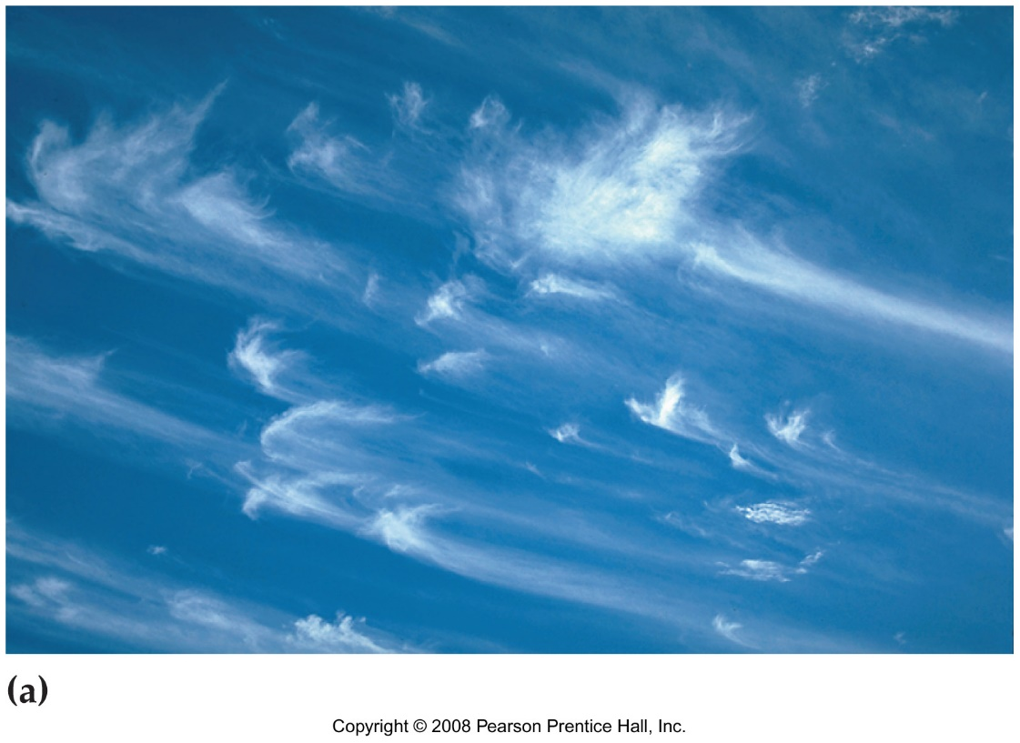

Stratiform clouds are spread out or layered clouds that cover most of the sky (below).

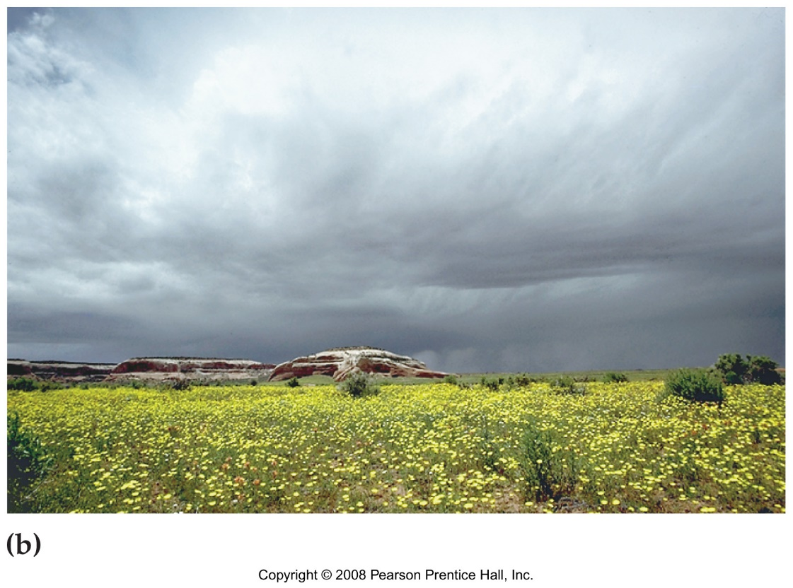

Cumuliform clouds are massive, rounded, and puffy clouds (below).

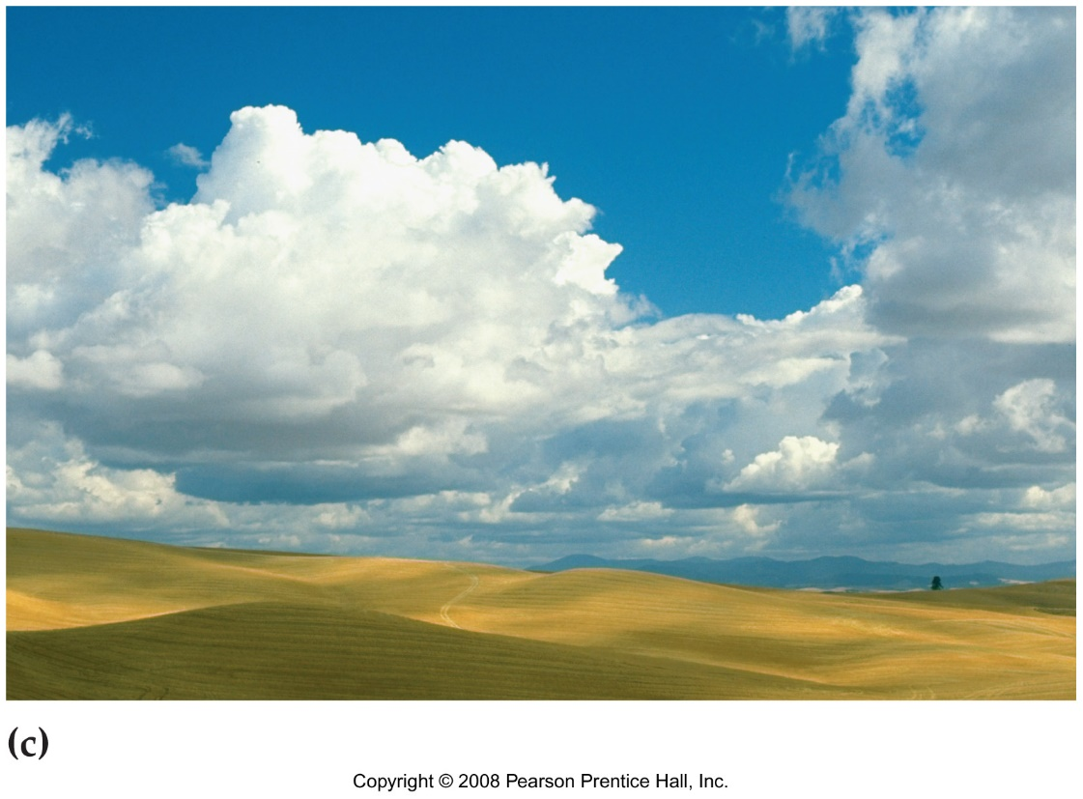

Cloud families grouped, based on shape and altitude.

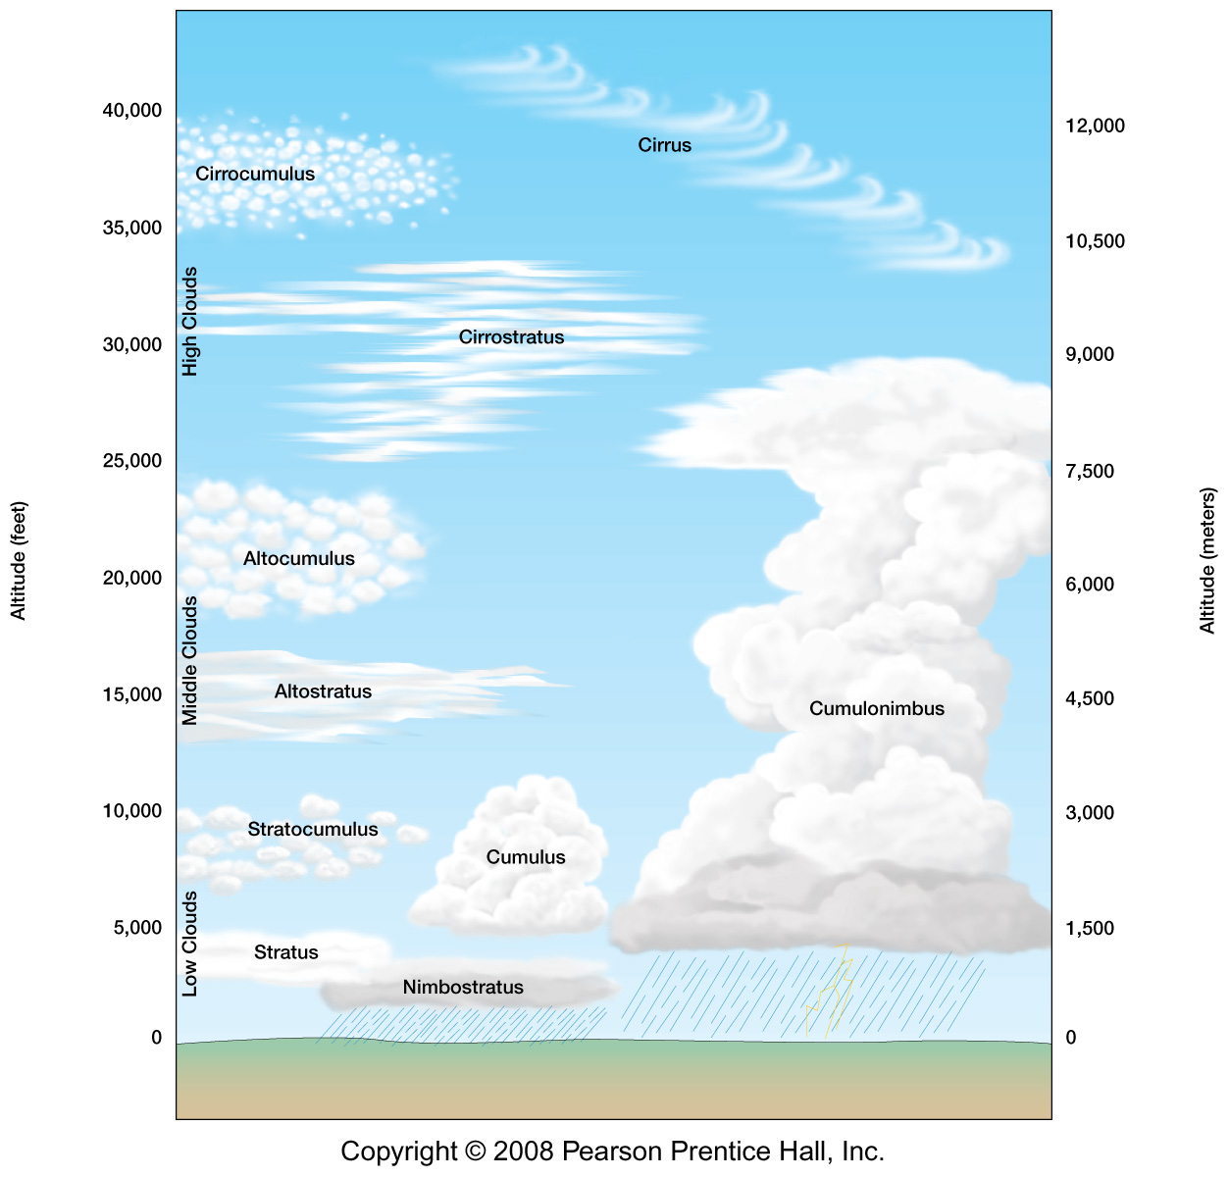

High clouds are generally above 6 km (20,000 feet), composed of ice crystals and include cirrus, cirrostratus, and cirrocumulus. High clouds often indicate approaching weather systems.

Middle clouds normally occur from 2-6 km (6500-20,000 feet), are composed of liquid water, and include altostratus (changing weather) and altocumulus (settled weather).

Low clouds, below 2 km (6500 feet) often appear as general overcast and include stratus, stratocumulus, and nimbostratus.

Clouds with high vertical development with heights up to 15 km (60,000 feet) indicate vertical motion in the atmosphere, including cumulonimbus clouds, which are storm clouds (example below in Arizona)

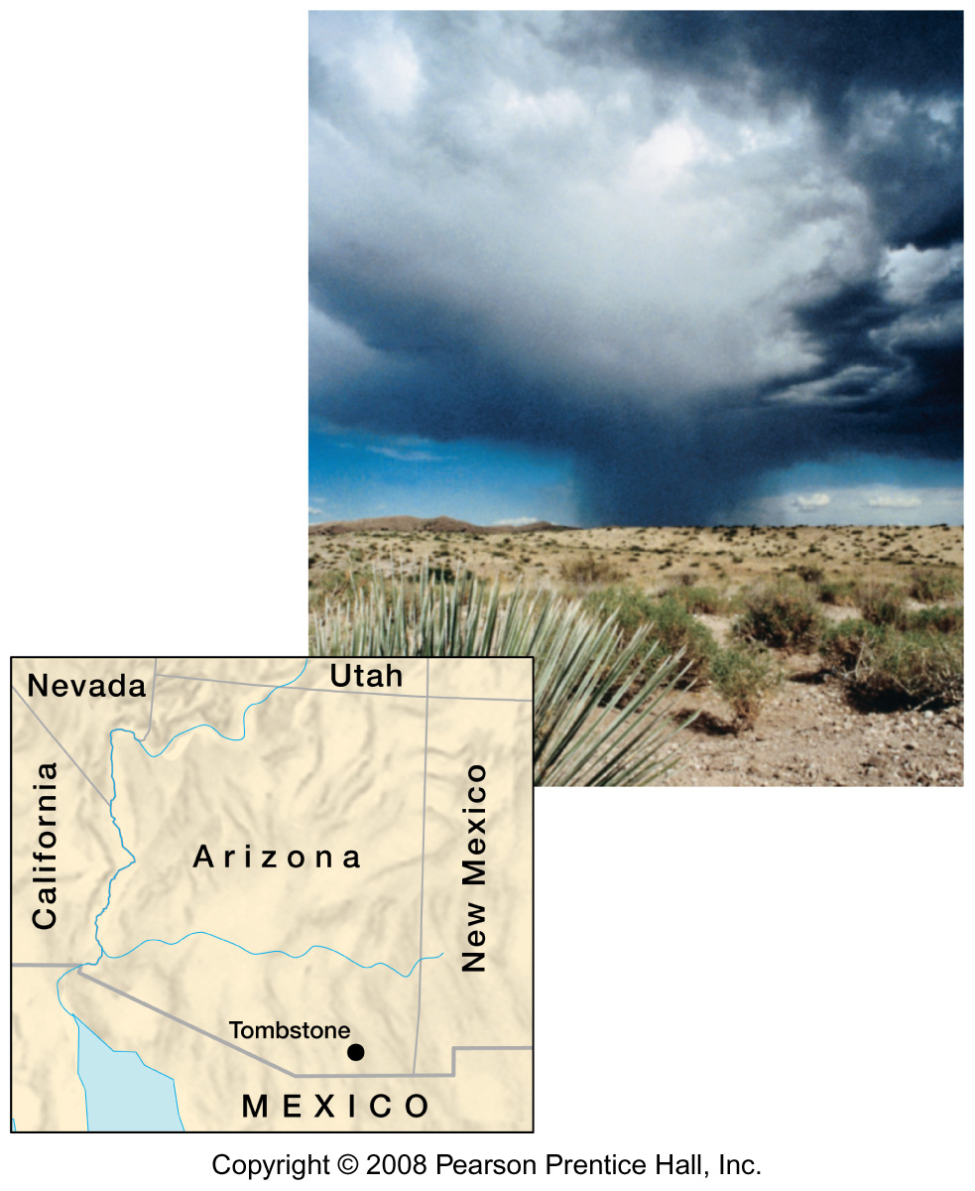

***Fog,*** a cloud on the ground may be caused by the ground radiating heat, usually at night to produce ***radiation fog***.

***Advection fog*** occurs when warm moist air moves sideways over a cooler surface (e.g. in the Tacoma narrows).

***Upslope fog*** results from the orographic effect when warmer moist air moves up a mountain.

***Evaporation fog*** forms over water when moisture is added to cooler air.

The stability of rising air is effected by the DAR and SAR relative to the lapse rate of the surrounding air.

When the DAR and SAR exceed the lapse rate of the surrounding air, the air mass is ***stable*** (top, below).

When the DAR and SAR are less than the lapse rate of the surrounding air, the air mass is ***unstable*** (middle figure, below).

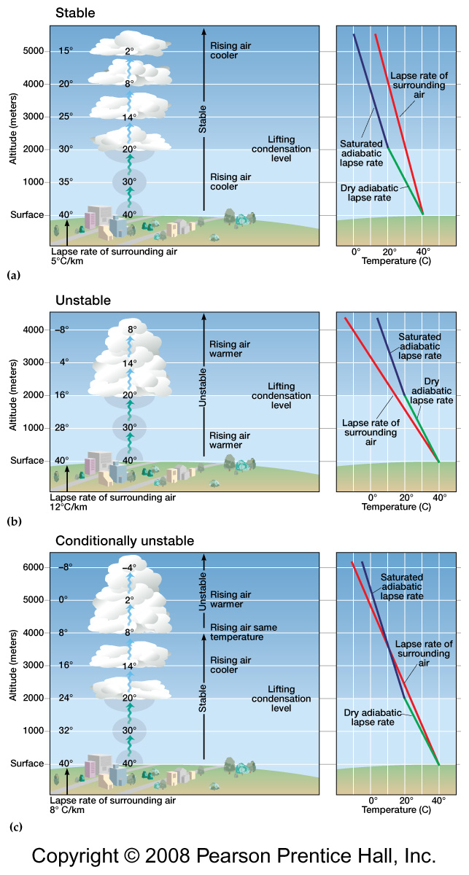

When the DAR is greater than the lapse rate of the surrounding air, and SAR is less than the lapse rate of the surrounding air, the air mass will become unstable when it reaches saturation (lower figure, above)

***Precipitation*** includes:

***Rain***: drops of liquid water,

***Snow***: ice crystals, pellets, or flakes (noting the variation of the water content),

***Sleet:*** rain that freezes during descent, and related ***glaze*** or “freezing rain”, where rain turns to ice on solid objects.

***Hail*** falls as pellets or lumps when strong convection in the atmosphere allows accretion of ice. Hail is associated with other severe weather, most frequently during the spring seasons.

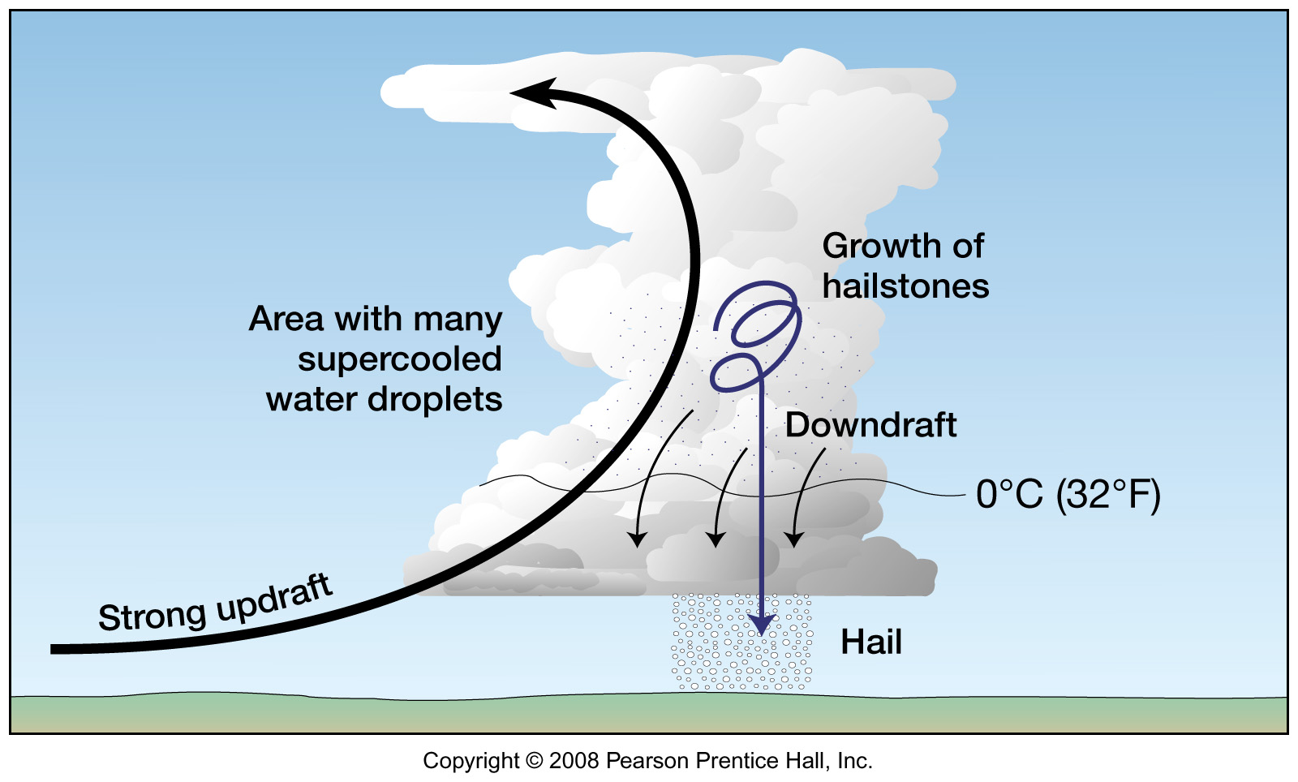

Note: recent very large hailstones recently recorded in Argentina:

<https://news.psu.edu/story/617800/2020/04/29/research/gargantuan-hail-argentina-may-have-smashed-world-record>

***Precipitation mechanisms***:

***Convective lifting*** or ***convection*** occurs as warm air heats up and rises. Convective precipitation is associated with thunderstorms, common on summer afternoons in areas where the land surface heats up during the day and warms the air above it. While thunderstorms are not too common in the Puget Sound area, they are very common in areas like eastern Washington and the U.S. Midwest. ***Convergent lifting*** is similar to convection, as we noted in the tropics where warm air rises and condenses in the equatorial region and air moves in the replace it.

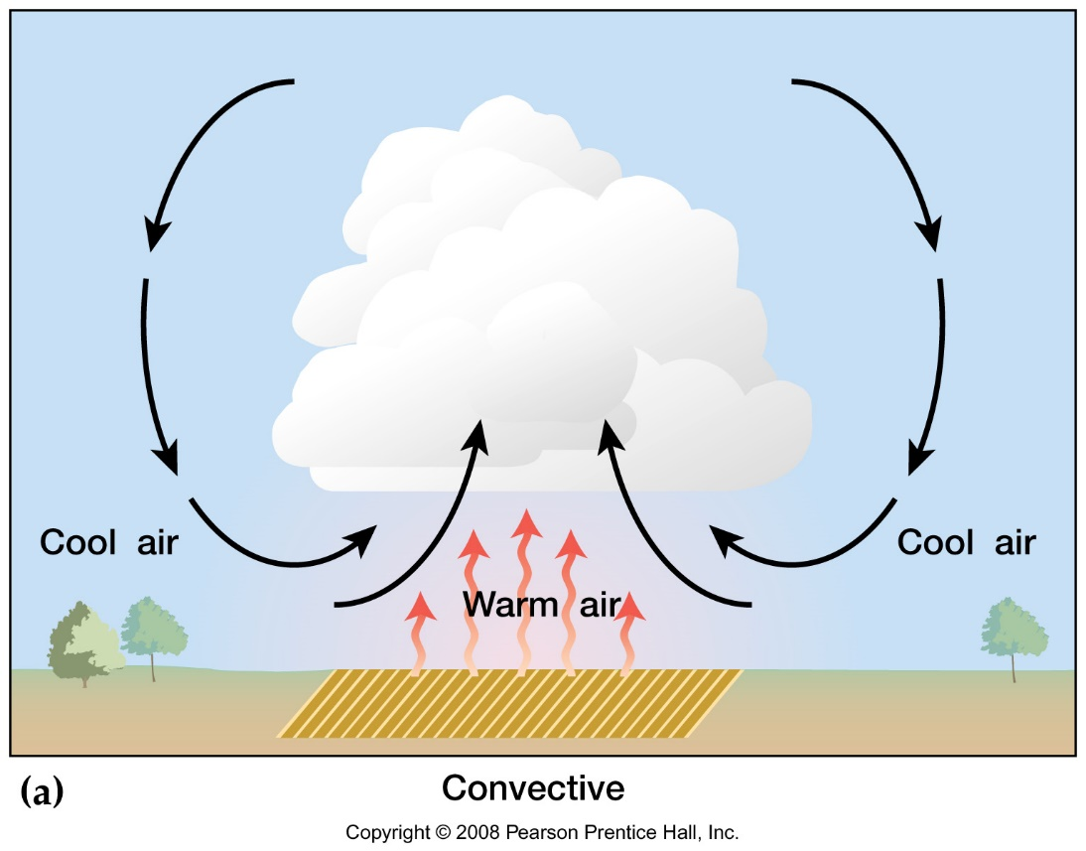

***Orographic lifting*** occurs when air is forced upslope and includes the rain shadow effect. Washington and Oregon provide great examples of the orographic effect, where air is forced upward over the Olympics or Cascade Range. We also study the orographic effect in lab 4.

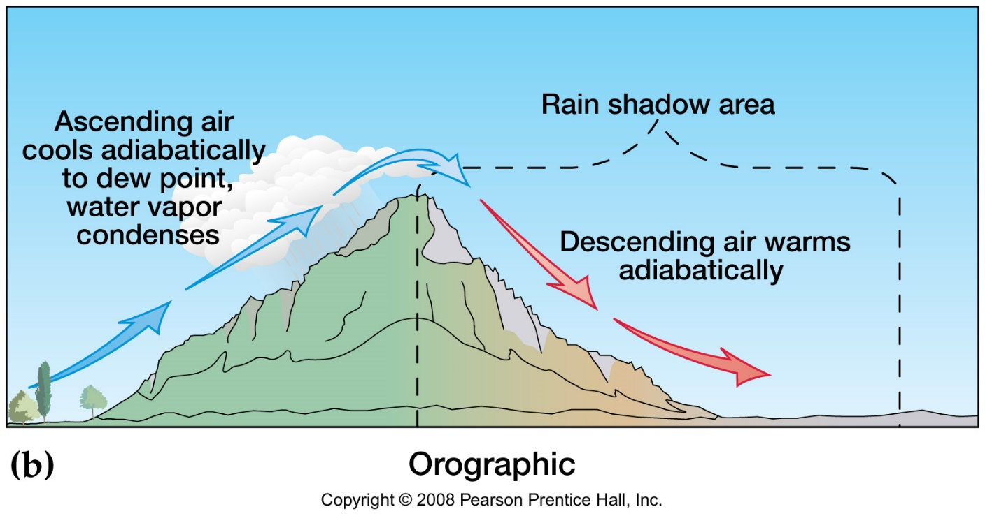

***Frontal lifting*** occurs along a boundary where air masses contrast and interact.

A mobile ***warm front*** (the direction indicated by the red bumps along a line on a weather map) overrides the colder denser air along a protracted (spread out) boundary of gradual lifting (below). Typical weather is multiple hours and days of rain.

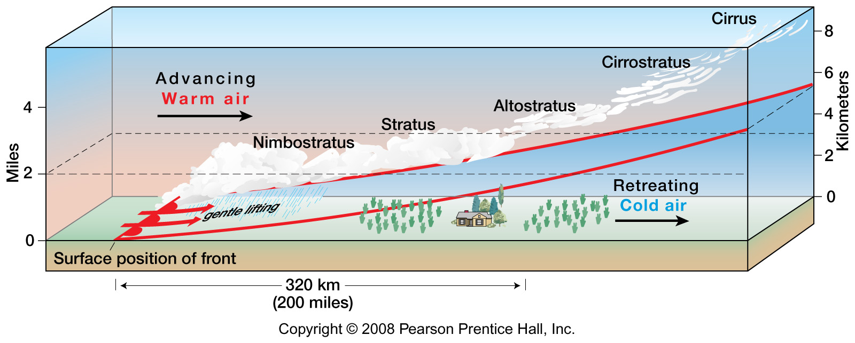

A mobile ***cold front*** (the direction indicated by the blue spikes along a line on a weather map) forms a narrower boundary where the colder denser air forces the warm air to lift abruptly. Cold fronts are associated with thunderstorms, hail, and severe weather.

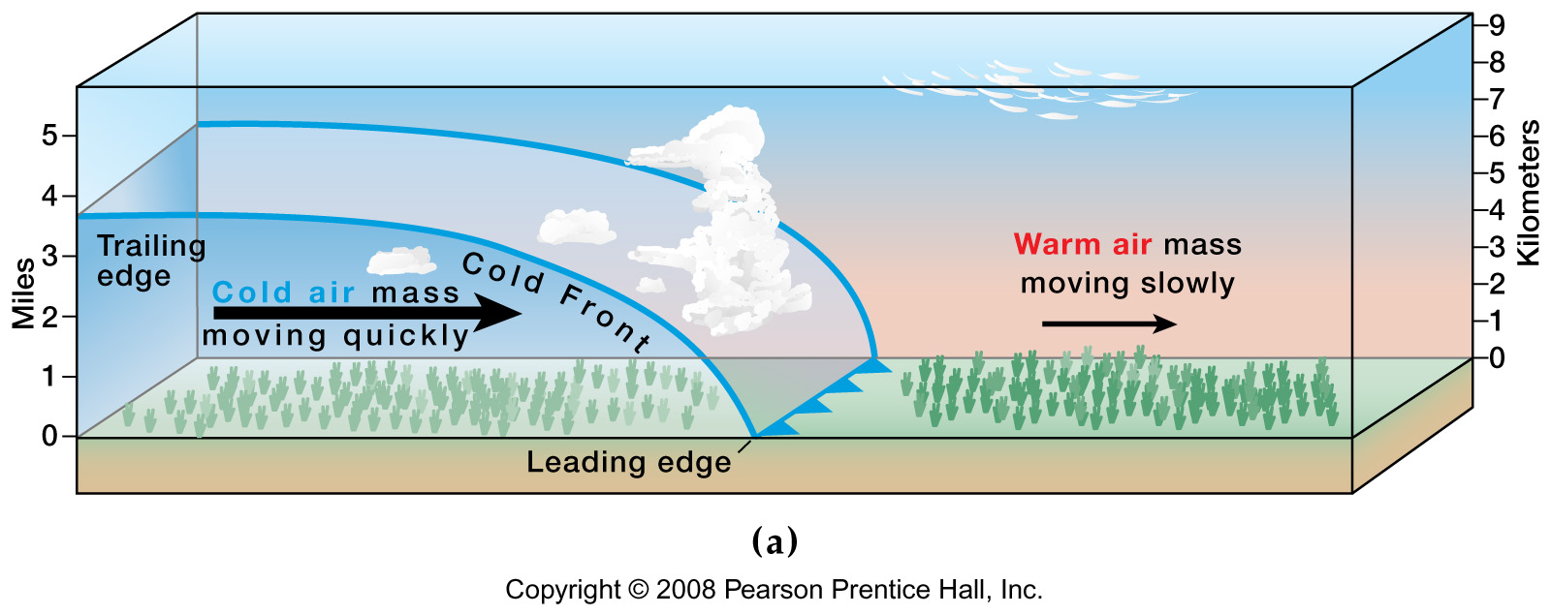

Areas of ***high annual precipitation*** include the tropics (ITCZ), the monsoon regions, and coastal areas in the latitudes of the westerlies (like Forks, Poulsbo/Silverdale/Bremerton, and Shelton). Areas in dark blue and blue show higher precipitation on map (below).

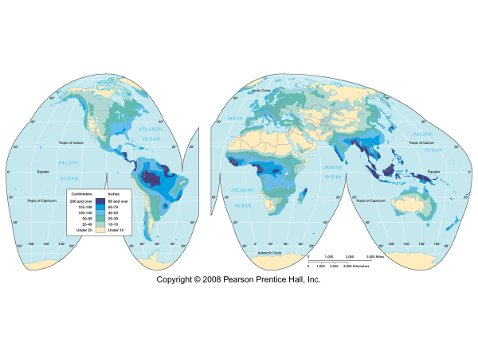

Regions of ***low annual precipitation*** in include the subtropical highs (STH), e.g., the Sahara of N. Africa, interiors of continents, e.g., central Asia, and the high latitude polar areas. Areas in tan show low precipitation on the map (above).

***Acid rain*** is a product of rainwater collecting acids as it falls through polluted air. In areas with higher industrialization and population centers, the pH of rainwater is typically lower (more acidic), e.g., in the U.S. (below).

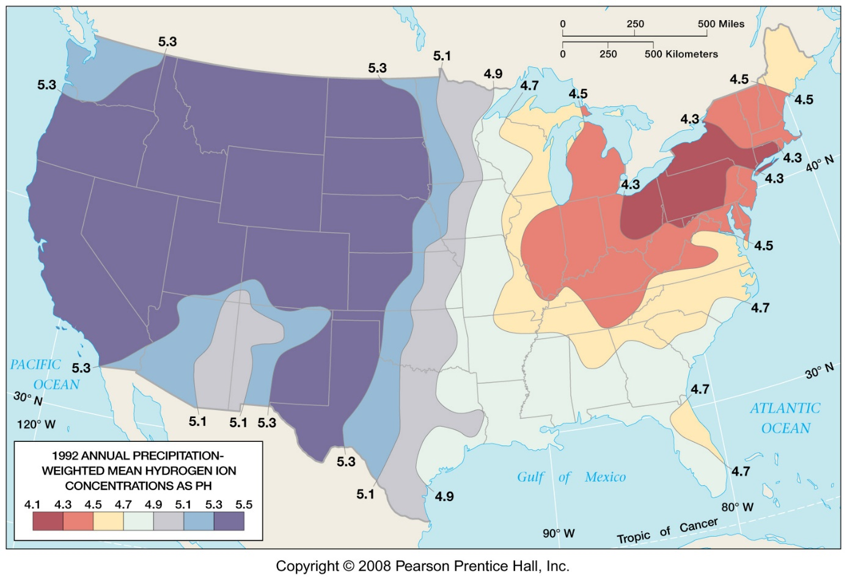

The sensitivity of the terrestrial environment to acid rain varies, depending on the bedrock geology and soils (see below). For example, granitic rock is acidic. When acid rain falls on regions with acidic bedrock the pH stays lower. This will cause environmental damage and loss of living things, e.g., dying fish in lakes of the Adirondack mountains in northern New York (shaded area on map, below).

If the bedrock or soils are basic, acid rain is buffered at the earth’s surface, neutralizing the acids, e.g., in stream water. An example of a basic rock is a carbonate or limestone, common in Kentucky, Ohio, and Florida.

